# Late Egyptian

## Taught by Foy Scalf

## Notes by Minh-Tâm Trinh

**3/5/2024**

**1. Introduction to Late Egyptian and How to Study It**

- Foy insists: Compare his sign list against Gardiner’s

- resources:

Lesko, *A Dictionary of Late Egyptian*, Vols. 1 & 2, Ed. 2

Černy–Groll, *A Late Egyptian Grammar*, Ed. 4

Junge, *Late Egyptian Grammar*, Ed. 2

Neveu, *The Language of Ramesses*

- three dimensions: language, script, register

- texts:

Contendings of Horus and Seth

Tale of the Doomed Prince

Tale of the Two Brothers

Quarrel of Apophis and Seqenenre

Tale of Wenamun

[Late Egyptian letters]

- Late Egyptian tends toward more analytic features

- “group writing” = syllabic writing

iw=f m sA wa n s aA

iw=f Hr Smi.t Hr tA mi.t

* As for him, [he] was behind one of an old[er] man.

* As for him, [he] was walking upon the earth [of] the road.

And he was behind an older man.

And he walked on the road.

- red dots on papyrus called “verse points”, but actually the marks of the proofreading scribe doing his job

- the letter A evolved from the mark used by Greek scholars to indicate “smooth breathing”, while the letter a evolved from that used to indicate “rough breathing”

- w often occurs at the end of words other than plural nouns: conjectured to indicate the vowel quality

- sometimes, group writing with the transliteration nr actually indicates a sound like l not present in the Memphite prestige dialect

- in Late Egyptian,

x often interchanged with X and S

q often interchanged with k and g (“develarization”: velar to uvular)

interchange of t, T, d, D

- will parenthesize implied feminine endings when unwritten besides being unspoken

tA sri.(t)

the daughter

- warning: some masculine nouns are written with a feminine t, due to group writing, as in the written ending of pA dmi

- another possibility: written reduplication of t due to group writing, as in dr.t=k

- assorted examples:

pA nTr aA

tA in.t aA.t

nA sr.w aAy.w

md.wt bin.w(t)

the great god

the great valley

the elder officials

(some) evil words

- for next week:

do readings from Late Egyptian grammars, study descriptions of grammatical constructions

memorize signs and vocabulary

finish week 1 exercises

start looking at week 2

**3/12/2024**

**2. The Late Egyptian First Present and Circumstantial Conversion**

- warning: in LE, unlike in ME, the genitival adjective usually does not decline! except in, e.g., honorifics and formal titles

- ⛵🛶🚤🛳️⛴️🛥️🚢

- note how irm is spelled irym: however we don’t know for sure what the y actually represented (a vowel?)

- Galen points out an example that requires context to disambiguate

pA xr aA sps

the great, noble necropolis

NOT

* the great necropolis of the noble

- apposition:

na wxA.w n Imn-Ra ny-sw.t nTr.w

the edicts of Amun-Re, king of the gods

- Mary: xAr would be Khar-, which sounds like Šur- as in Syria! Rachel: More accurately, Ašur, as in Assyria

- onomatopoeic words:

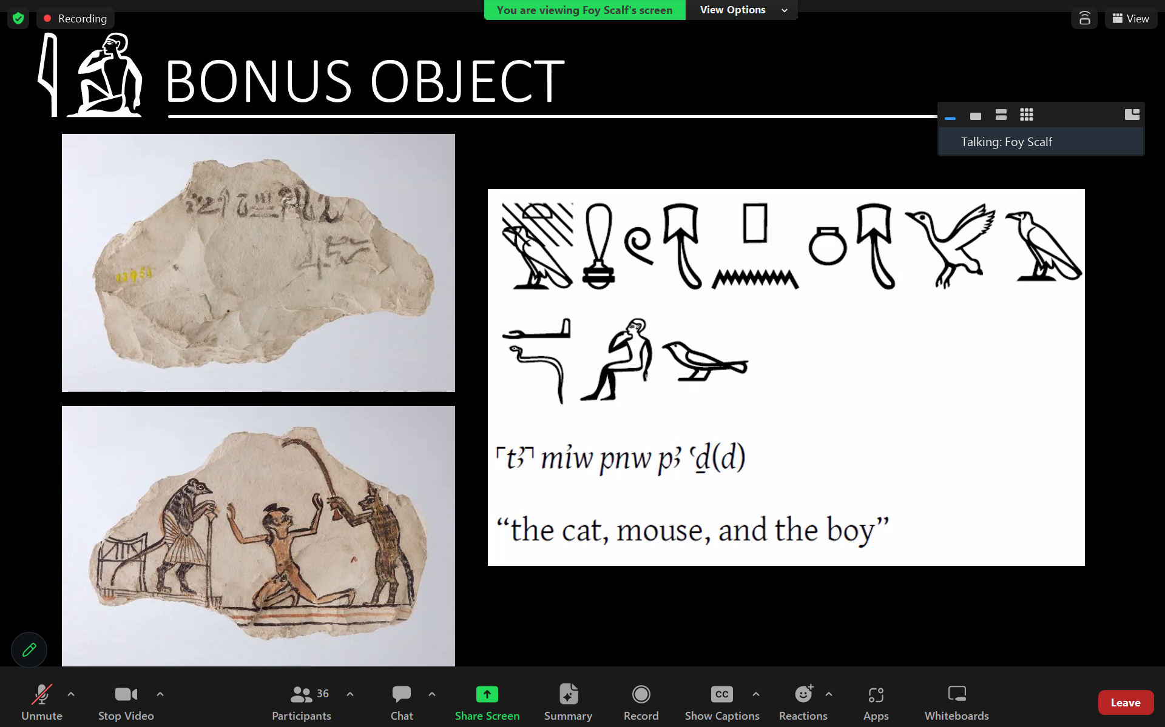

- someone with username “R B”: “cat” becomes ⲉⲙⲟⲩ in Coptic

- LE di replaces ME a for “hand, arm”

- in general, -w replaces -sn as the default 3rd-person plural suffix pronoun: -sn now sounds more formal

- warning: in LE, unlike in ME, suffix pronouns bind to nouns only in the case of (a limited set of) inalienable nouns: e.g., body parts

- instead, suffix pronouns in LE bind to articles to form *possessive articles*:

tAy=f Sri

NOT

* tA Sri=f

his daughter

- also notice that Sri replaces sA, sA.t

- *pronominal compounds* in LE occupy subject slots, but do not replace independent pronouns:

tw=i tw=n

tw=k, tw=t tw=tn

sw, st

tw=tw

- LE mostly gets rid of passive forms, using pronominal compounds to convert passive constructions to impersonal active ones

- LE also uses pronominal compounds to avoid saying the name of the king, converting it to “the Royal One…”

- the *first present* construction: bipartite, consisting of NP + AdvP

- two examples that show a reversal from ME: the example with the pronoun has nothing in front of it, whereas in ME, we would require an iw

pAy=i it im

tw=i im

My father is there.

I am there.

- LE bn replaces ME *nn* to negate the predicate; statement sometimes concluded with iwnA:

bn pA aA m-di=i

xr bn tw=i m pAy=i sxr.w iwnA

The donkey is not in my possession.

Now, I am not in my (normal) way(s).

- Rachel: isn’t nn to bn an unusual phonological evolution? Foy: yes, there was also a mn used to mean “There is/are not…”, and which was probably part of this evolution

- bn … iwnA evolves into a negation construction in Coptic

- note that the first present, despite the name, does not indicate a tense: tense will be marked by *converter* particles

- so far, we’re only discussing the nonverbal first present, but there is a verbal version

- the converter for the *circumstantial first present,* which corresponds to an English dependent clause “…, while…”, is iw (!)

- the circumstantial converter replaces the tw= part of the pronominal compound, and precedes the negating particle bn

iw pA rmT m pr

iw bn pA rmT m pr

iw=i m pr

bn tw=i m pr

…while the person is in the house.

…while the person is not in the house.

…while I am in the house.

…while I am not in the house. / I am not the house.

- extended example:

xr ir Inpw

sw xr pr xr Hm.t

iw pAy=f sn-Sri m-di=f mi sxr m Sri

Now, as for Anubis,

he had a house and wife,

while his younger brother was with him in the way of a son.

- uses of iw:

circumstantial first present

continuative or NIMS (“Non-Initial Main Sentence”) clauses, which have the form iw=f (Hr) sDm (“And, __ listens/listened…”) and are negated by tm

*third future*

- for next week:

do readings from Late Egyptian grammars, study descriptions of grammatical constructions

memorize signs and vocabulary

finish week 2 exercises

start looking at week 3

**3/19/2024**

**3. The Infinitive and the Stative in the First Present and Late Egyptian**

- as the force of the demonstrative adjectives in ME was reduced to that of definite articles in LE, these words took on possessive functions?

- in the spelling of m Dr.t=k, the second t occurring in tw merely indicates that the t was pronounced, not just written as part of Dr.t

- pr-HD for “treasury”, with honorific transposition when written:

iw=w m-Xnw pAy r pr-HD

…when they were inside the doorway of the treasury.

- note that the replacement of =sn with =w is not a phonological shift: it’s grammaticalization of the plural marker

- restoration of m in transliteration:

ist iw pAy=f sn Sri (m) aHAwty nfr

…so his younger brother was a good man[…]

- from P. BM EA 10185, recto 1.1

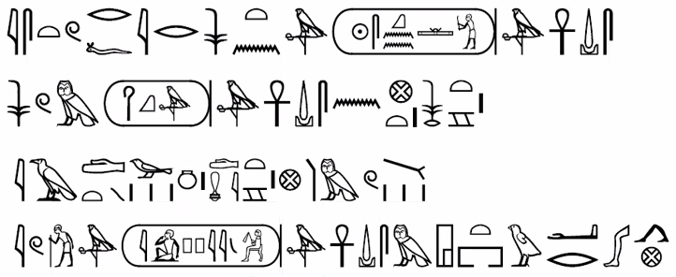

ist r=f ir ny-sw.t Sqnn-Ra a(nx) w(DA) s(nb)

sw m HqA a(nx) w(DA) s(nb) n niw.t rsy.t

iAd.wt m dmi aAm.w

iw wr Ippy a(nx) w(DA) s(nb) m @w.t-war.t

…so as for the king, Seqenen-Re, l.p.h.,

he was ruler, l.p.h., of the southern city.

Miseries were in the town of the Asiatics,

when the chief, Apophis, l.p.h., was in Avaris.

- *dependent pronoun* series:

wi n

tw, ti twtn

sw, st sn, st

- uses of dependent pronouns in LE:

direct objects of verbs

as subjects of clauses with adjectival predicates

in higher registers, uses closer to ME uses

- dependent pronouns beginning to be replaced with *direct object pronouns*:

tw tw=n

tw=k, tw=t tw=w

tw=f, tw=s st

- Rachel: do the direct object pronouns come from the impersonal tw? Foy: no; but in fact, that’s probably how the pronominal compounds evolved

- we believe the pronominal compounds were formed from tw, while the direct object pronouns were formed by generalizing, then re-grammaticalizing, the infinitive ending -t: thus the similarity between these pronouns would be merely coincidental

- example of use as direct objects:

wn.in=f xsf tw=f

Then he answered it.

iw=tn Hap tw=f r=i

You will conceal it from me.

- absolute, construct, and pronominal (i.e., with suffix pronoun) states of the infinituve evolved into corresponding forms in Coptic

- use of the infinitive in the first present:

with Hr, less common:

pA wpwty Hr Smi.t

The messenger is walking.

Ra Hr xw=f

Re is protecting him.

tw=n Hr mw.t n Hqr

We are dying of hunger.

tw=i Hr Dd n PA-Ra

I am speaking to Pre [Pa-Re].

without Hr(!), actually more common:

tw=i iri=f n=i m Sri

I am making him as a son for me.

xr ir sw amA nA btA.w

Now, he learned[?] about the crimes.

- the continuative / NIMS is our name for iw=f (Hr) + sDm, where sDm can be replaced by either an infinitive or a stative

- the third future has a similar construction: iw=f (r) sDm

- no gemination in LE!

- other names for the stative: pseudo-participle, old perfective, resultative

- stative endings in LE:

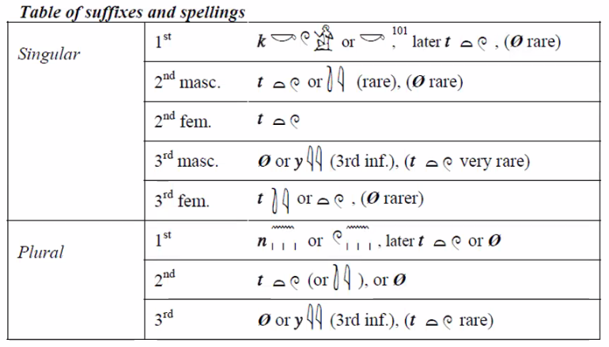

**3/26/2024**

**4. The sDm=f Forms of Late Egyptian**

- way to think about the Egyptian stative: high-transitivity verbs in the stative are translated with passive voice; low-transitivity verbs, like verbs of motion, are translated with active voice

tw=i sDm.kwi

I was heard.

NOT

* I heard.

- the third future in LE is similar to the indicative future in English

- one drawback of using Černy–Groll, etc. for a beginner course: they list ALL the exceptions up front

- from Coptic, we know that the stative had a different pronunciation from the infinitive in LE, irrespective of the endings

- due to the distinct pronunciation, the stative began to be spelled without its endings in LE, and these endings almost disappear in Demotic

- with verbs of motion, the Hr + infinitive construction usually becomes m + infinitive, the main exceptions being mSa and Smi

- nonetheless, m + infinitive becomes very rare in LE, except in high-register texts

- wn.in is the “narrative imperfect” converter

- Dentals in LE all merging together, resulting in written t’s that are likely phonetic(!) complements rather than, e.g., infinitive markers

iw=f Hr di

NOT

* iw=f Hr rdi.t

* iw=f Hr di.t

Tiensirin: nonetheless, the -.t could also be a feminine suffix pronoun!

- definite article vs. demonstrative adjective:

nA n rmT.w

nA.y n rmT.w

nn rmT.w

the people

these (of the) people

these people

- ym, “sea”, is a borrowing from some Semitic or Canaanite language

- the “extra” signs in LE spellings can mislead, e.g., with noun gender, so rely on other cues:

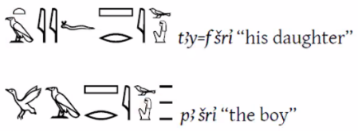

- extended use of the continuative:

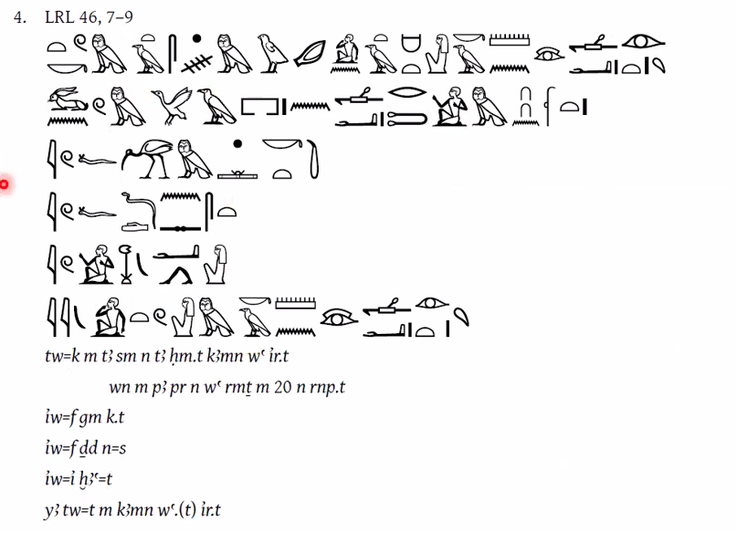

You are in the situation of the wife blind in one eye,

when [she] was in the house of a man for 20 years,

and he found another,

and he said to her:

I divorce [“abandon”] you.

Indeed, you are blind in one eye.

- second-to-last line here is tricky:

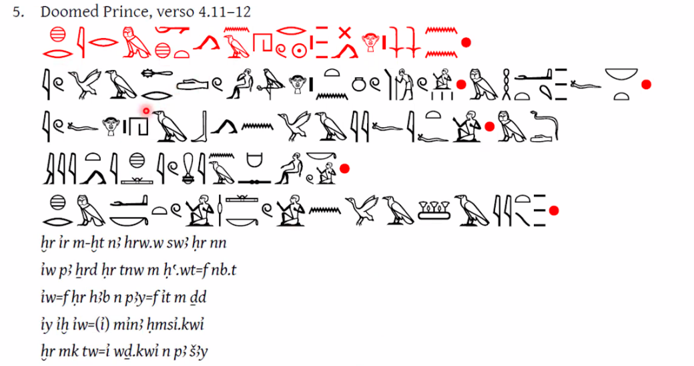

Now, after the days passed concerning this,

the child grew older in all his limbs,

and he sent word to his father, saying:

What has happened, while [I] am here waiting?

Now, look, I am destined to [“the”] fate.

- LE sDm=f forms:

perfective sDm=f (a.k.a., preterite, perfect, …)

prospective sDm=f (a.k.a., subjunctive, …)

nominal sDm=f (a.k.a., second-tense, emphatic, …)

- these sDm=f forms have the same outward appearance when used “positively”, but their negations look different

- LE perfective sDm=f developed into the periphrastic use of iri, in iri + infinitive, and later into Coptic ⲁϥⲥⲱⲧⲙ

- perfective and prospective sDm=f are sentence-initial

- perfective sDm=f negated by bw-pw=f sDm, while prospective sDm=f negated by bn sDm=f

- prospective sDm=f can follow:

rdi as a causative: di sDm=f

ix, “please”

m-Dr or other prepositions/conjunctions

**4/2/2024**

**5. Nominal Predicates in Late Egyptian**

- the LE present- & past-tense verbal system:

independent present tw=f sDm

dependent present iw=f sDm

negated independent present bn tw=f sDm iwnA

negated dependent present iw bn tw=f sDm iwnA

independent past sDm=f

dependent past iw sDm=f

negated independent past bw-pw=f sDm

negated dependent past iw bw-pw=f sDm

- Demotists often read Hsb.t as Hat-sp by tradition, but this is actually incorrect: this tradition started from a (mis)reading of a Ptolemaic inscription where Hsb.t was spelled out phonetically

- in many ways, LE works exactly the opposite of ME

Dd=f

he said

OR

saying it

NOT

* his saying

- wn = imperfect converter; wn.in = narrative imperfect converter

wn=i sDm

I heard

- LE no longer has a sDm.n=f! it’s replaced by the perfective sDm=f

aHa.n Dd n=s tA PsD.t

NOT

* aHa.n Dd.n=s tA PsD.t

Then the Ennead said to her

- example of a continuative followed by a perfective sDm=f:

iw=s Hr Dd n=f

ptr di pAy=k nTr wa m nAy=k Saw.w m Dr.t=k

And she said to him:

Look, your god has put one of your fates in your hand.

- remember that there are three words for day: ra, hrw, sw; the last one is the one used in calendar dates

- example of active voice used to convey a passive construction:

O. DeM 73, 4

Hsb.t 20 Abd 2 Ax.t sw 10

hrw pn Dd iri.n qd !rw-nfr Hna Any-nxt m-bAh sS n tmA Imn-nxt

iw=tw Hr swD n=f pA aA bin

Regnal year 20, month 2 of Inundation, day 10.

On this day, the testimony that the builder Heru-nefer made against Any-nakht in the presence of the scribe of the magistrate Amun-nakht.

And the bad donkey was transferred to him.

(“And one transferred to him the bad donkey.”)

- Galen: “Interesting that Hna can be translated “against” due to context—not in Lesko as such.”

- example of a prospective sDm=f:

anx rmT.w mnmn.t m inw.w=f n SA.w nb

May [the] people and cattle live from his gifts of all [the] fields.

- translate mtr.t as “true” in the sense of “accurate” rather than *maat*:

HA.t-a m sbAy.t mtr.t Ts.w n wA.t n anx

Beginning of [the] true teaching, sayings for a way of life.

- demonstratives can function like in ME (though have other functions; see below):

Dd n=f TAty

i Dd my n=i pA di=k pAy HD im

The vizier said to him:

Tell me, please, the place where you put this silver.

- independent pronouns and their evolution:

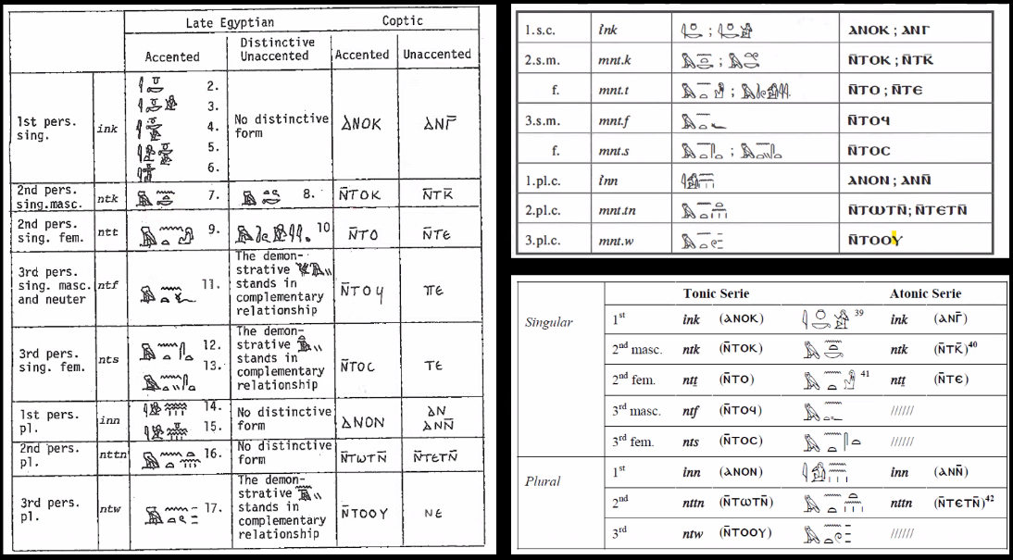

- uses of independent pronouns:

“subject” of a sentence with nominal predicate

possession

emphasis

- possible structures for sentences with nominal predicates:

independent pronoun + NP

NP + pAy/tAy/nAy + NP

NP + NP + pAy/tAy/nAy

Sri pAy

As.t wr mw.t-nTr tAy

He is a son.

She is Isis, the great, [the] god-mother.

- note: pAy/tAy/nAy always follows the predicate!

- how this is explained in Černy–Groll, etc.:

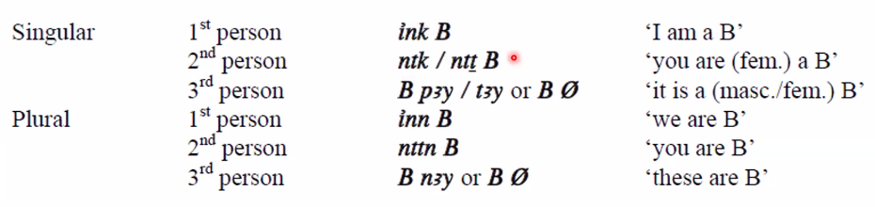

- Foy believes that A + B constructions where both A and B are NP’s, not pronouns or demonstratives, are extremely rare, and that most examples in grammar books are actually adverbial predicates with a hidden m: in other words, A B is really A (m) B

- “Now, we don’t have time—in fact, we're out of time…”

- nominal predicates negated using bn ___ (iwnA)

bn mntk rmt iwnA

You are not a man!

**4/9/2024**

**6. The Imperative and the Conjunctive**

- tw=k mi=k “How are you?”

- for the best transcription + transliteration of LE stories: Bibliotheca Aegyptiaca I, edited by Gardiner

- for the best transcription + transliteration of LE letters: Bibliotheca Aegyptiaca IX, edited by Černy

- summary of LE predicates:

nonverbal

adverbial (first present + satellites)

nominal

A B

A B pAy/tAy/nAy

A pAy/tAy/nAy B

adjectival

ny sw A

verbal

perfective sDm=f

prospective sDm=f

nominal sDm=f

- the stacking of pAy’s can get confusing: below, the first pAy is part of a possessive adjective, while the second indicates the nominal predicate

pAy=k iti pAy

He is your father.

- Doomed Prince, 7.2–4 [with Galen’s help in wording the seventh line]:

ptr tw=k m-di=i m Sri

iw=f Hr Dd n=f

ink Sri wa n snny n pA tA n Km.t

iw tAy=i mw.t Hr mwt

iw pAy=i it Hr iri.t n=f k.t Hm.t

iw=s Hr xpr Hr msdy=i

iw=i Hr iy.t m war r HA.t=s

wn.in=f Hr di n=f tAy=f Sri r Hm.t

Look, you are as a son with me.

And he said to him:

I am the son of an officer of the land of Egypt.

And my mother died.

And my father took [“made”] for himself another wife.

And she came to despise me.

And I came to flee from before her.

Then he gave to him his daughter as wife.

- above, note the broad semantic range of iri, which we usually only translate as “to do, make”: it also shows up in the idiom for “to pass the time”

- repeated use of the independent pronouns:

mntk nby nTr.w m qAi=sn

mntk iir anx=sn

[…]

mntk pAw.ty tpy

Hr=k n=i

ink sAw-a

You are the goldsmith of the gods in their forms.

You are the one who makes their life.

[…]

You are the first primeval one.

Your face is toward me.

I am weak of arm.

- Wenamun, 1.12–14:

iw=i Dd n=f

tw=i TAi.tw n tAy=k mr

xr mntk pA wr n pAy tA

xr mntk pAy=f smty

And I said to him:

I have been robbed [stative] in your port.

Now, you are the leader of this land.

Now, you are its judge.

- the particle ix used to mean “Please…”:

ix Dd=tn n Imn nb ns.t tA.wy Mr-sgr

Please, may [prospective] you say to Amun, lord of the throne of the two lands and Meretseger.

- “95%” of verbal roots look the same in the imperative as in the infinitive, but a few have a prefix (or “prosthetic”) i.-

i.Dd

i.ir

i.hAb n=n a=k

Speak!

Do!

Write to us how you are [“your condition”].

- verbs with special imperative forms:

mi

imi sw n=i

Come!

Give it to me!

- So Miyagawa: the LE imperative i-prefix looks like the Coptic imperative ⲁ-prefix

- whereas the direct objects of LE infinitivets are suffix pronouns, the direct objects of LE imperatives are dependent pronouns

tw=i sDm=f

sDm sw

I heard it.

Hear it!

- the imperative is negated by m, in which case there is no prefix i.-, because it’s technically a separate verb form taking a negatival complement, just like in ME

m ir Dd=f n=i a n

Don’t say that to me again.

- the conjunctive takes the form mtw + [subject] + [infinitive]

- the conjunctive continues the semantic meaning of the preceding clause, so we translate it as a NIMS clause with “…and…”:

Dd n=i in n=T tAy aDd.t Srit mtw=T dit n=i swn(t)=s

Buy from me for yourself this young girl and pay me her price.

- conjunctives can be strung together endlessly in informal language, as in this excerpt from a letter:

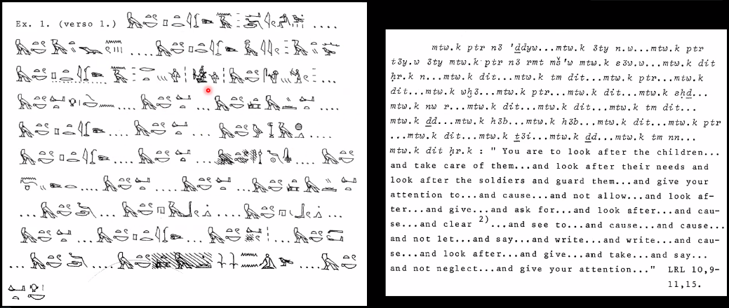

- Gardiner proposed that the “conjunctive morpheme” mtw actually evolved from the ME independent pronoun series:

iw=f r sDm iw=f r md.t

→ * iw=f r sDm Hna md.t ntf

→ iw=f r sDm Hna ntf md.t

→ iw=f r sDm mtw=f md.t

- the conjunctive persists into Coptic!

**4/16/2024**

**7. The Third Future and Relative Clauses**

- to use Ramses Online, it’s necessary to type queries in FRENCH not English (e.g., “Moscou” not “Moscow”)

- verb forms covered (and not covered) in this class:

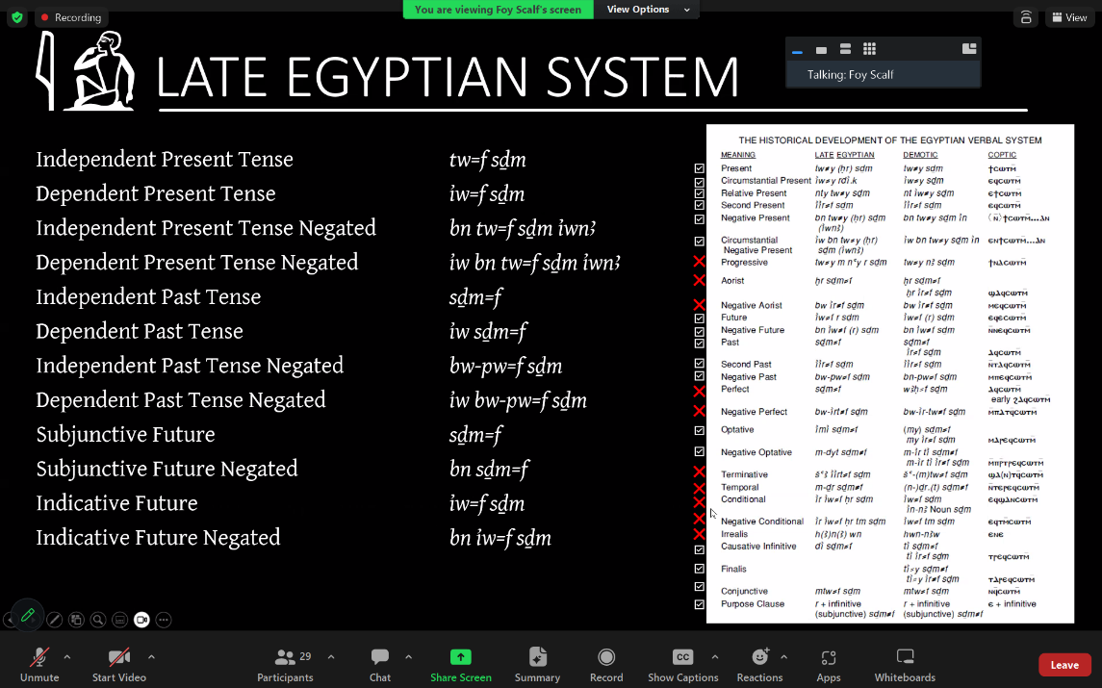

- Galen on the “circumstantial negative present”: “I was puzzled by iw bn tw=f sDm iwnA because it seems to duplicate the independent and the dependent morphology. Why wouldn’t it be iw=i bn sDm iwnA?” Foy: break it down into converter + negation + first present

- “I don’t know if I’m scaring you or if I’m inspiring you…”

- Egyptologists borrowed the term “aorist” from Greek studies, but give it an opposite(?) usage

- why the difference below?

tw=k mi ix

sw mi ix

NOT

* tw=f mi ix

How are you?

How is he?

- note how the syllable mi is usually spelled with the group writing: m-owl + a-arm

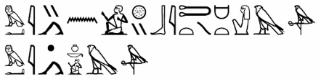

mi n=i sp-sn BiT.t Hm.t Hr

mi ink Hr

Come to me [emphasis]! Bichet, Wife of Horus.

Come. I am Horus.

- for more on the Seven Scorpion Wives of Horus: check out Ritner’s lecture about it on YouTube

- The scorpion wears a dress and bracelets:

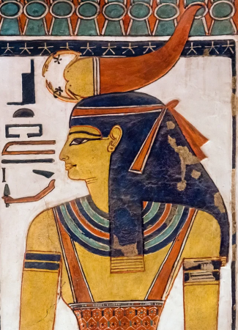

- example of active construction with passive meaning, followed by a relative:

wn.in=s Hr Dd n=f

imi di=tw Xdb pA iw nty m-sA=k

iw=f Hr Dd n=s

wxA

Then she said to him:

Have the dog which is behind you killed [“Cause that one kill the dog which is behind you”].

And he said to her:

Foolishness.

- a spell about the Scorpion Wives (taken from <https://www.metmuseum.org/art/metpublications/The_Art_of_Medicine_in_Ancient_Egypt>):

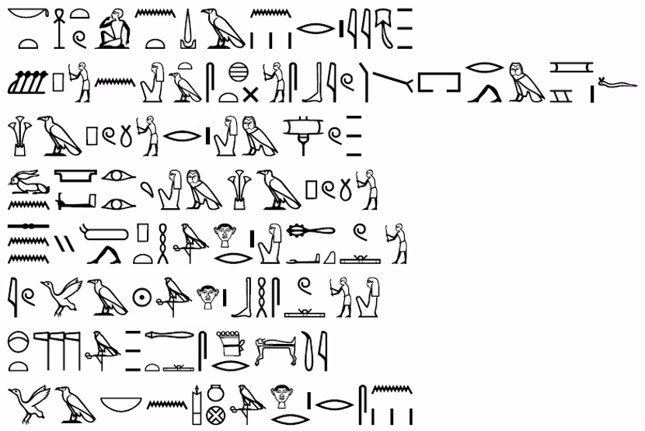

k.t Sn.t n.t DAr.wt

Ssp n=t tA sx.t sbi pri m mr=f

HAp rA=t m TAw

wn ir.ty=t n hAp

sni PtH Hr=t Haq

iw PA-Ra Hr bHs=t

PsD.t aA.t sDr.ti

pA Nb n Iwnw Hr=sn

Another incantation of scorpions.

Receive for yourself the blow of the rebel who has come forth from his canal.

Cover your mouth within a sail.

Open your eyes in hiding.

May Ptah pass by your shaven face,

while Pre pursues you.

The great Ennead has passed [stative?] [the night].

The Lord of Heliopolis is upon them.

- note how Hr is spelled with two r-mouths in the last line, hinting that the pronunciation has become reduced in LE *except* when a suffix pronoun preserves the ending -r

- John Sarr: “The Metternich Stele is also a good source of [the] Isis and the [S]even [S]corpions story”

- the conjunctive is more likely to follow a prospective / future / imperative than a present:

iry=k Smi.t r pAy=n pr

mtw=k aq r iHw

May you go to our house

and enter the stable.

- from the famous Egyptian–Hittite treaty:

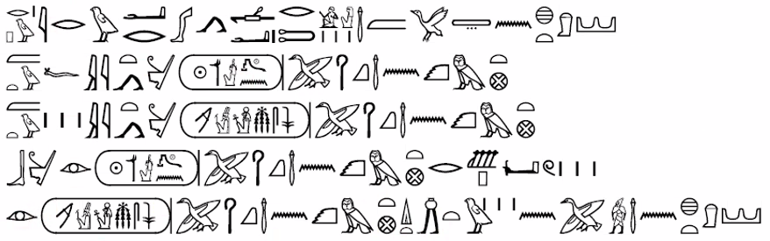

rA-pw ir war wa rmT aA m pA tA n #tA

mtw=f iy.t n Wsr-mAa.t-Ra %tp.n-Ra pA HqA aA n Km.t

mtw=w iy.t n RA-ms-sw mri Imn pA HqA aA n Km.t

bn iri Wsr-mAa.t-Ra %tp.n-Ra pA HqA aA n Km.t r Ssp=w

iri Ra-ms-sw mri Imn pA HqA aA n Km.t di.t ini.t=w n pA wr aA n #tA

Or, if a great man should flee from the land of Hatti,

and he come to Usermaatre Setepenre, the great ruler of Egypt,

and they come to Rameses, beloved of Amun, the great ruler of Egypt,

Usermaatre Setepenre, the great ruler of Egypt, will not receive [third future] them.

Rameses, beloved of Amun, the great ruler of Egypt, will cause [third future] that one bring them to the great leader of Hatti.

- Rachel: the Hittites put extradition clauses into all of their treaties because of how their inheritance [laws] worked

- Cy: “The Egyptian version on the monuments was translated from Akkadian[;] it even refers to the Hittite seal that was on the Akkadian metal tablet”

- for further reading, Cy suggests *Hittite Diplomatic Texts* by Gary Beckman

- the *third future* is the indicative future verb form, just as the prospective is the subjunctive future verb form:

iw=f r sDm

bn iw=f r sDm

He will hear.

He will not hear.

- r can be omitted from the third future, just as Hr can be omitted from the first present

- the initial iw in the third future is often replaced with iri, as is (probably) occurring in the excerpt above from the Egyptian–Hittite treaty

- why this iw to iri replacement? we believe the two words sounded similar, so that this replacement would just be orthography to disambiguate the third future from the circumstantial first present

- circumstantial conversion of the third future will result in two iw’s, which will actually allow us to avoid further ambiguity:

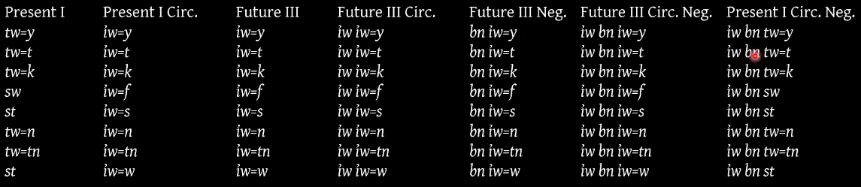

- “adverbial subordination makes it particularly clear that th iw in the Third Future belongs to the morphology of the form itself”:

[mtw=k] Aty n=s iw iw=k gm=s r ir.t nAy=k ipw.ty im=s

[…and you will] be careful with it [the boat], for you will find it useful for carrying out your tasks.

- nty is the only relative converter in LE

- some subtlety:

pA rmT nty sw m-di=f

the man with whom he is

NOT

* the man who is with him

- occasionally, resumptive pronoun absent:

iw=i (Hr) Sm r pA nty pA wr im

I went to the [place] in which the prince was.

**4/23/2024**

**8. Relative Forms, the Second Tense, and Second Tense Conversion**

[missed most of this class due to an airplane flight]

- like imperiatives, relative forms are usually preceded by a prosthetic *yod*, which is sometimes written instead with an r mouth

- we can distinguish relatives from imperatives by the presence of a subject in the former:

tA Sa.t i.di pA rmT n sn.t=f

the letter which the man gave to his sister

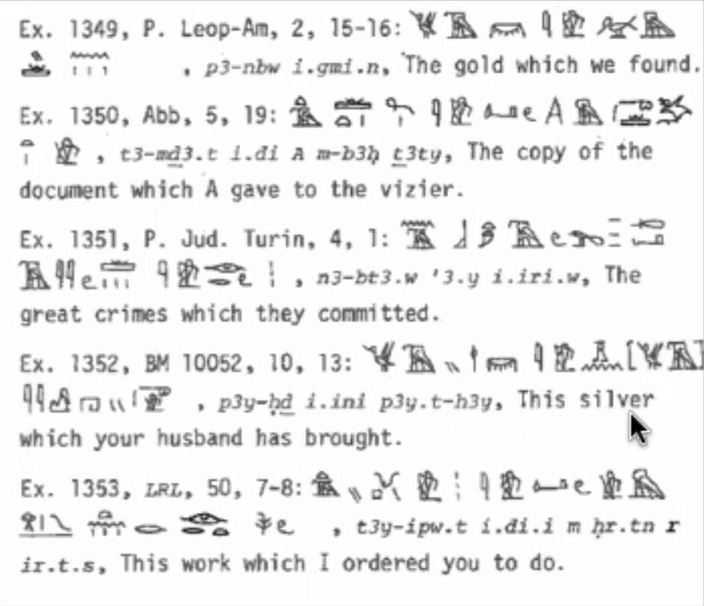

- recall that the purpose of a second-tense clause is to emphasize the adverbial phrase that follows

- very unfortunately(?), second-tense forms are also marked with a prosthetic *yod*

- the second-tense construction has the general form

i.sDm=f / i.ir=f sDm

+

one of

[preposition] + [noun phrase]

r + [infinitive]

iw + [sentence conjugation]

[clause conjugation]

i.ir=k iTA Ax.t=i Hr ix

Why did you take my property?

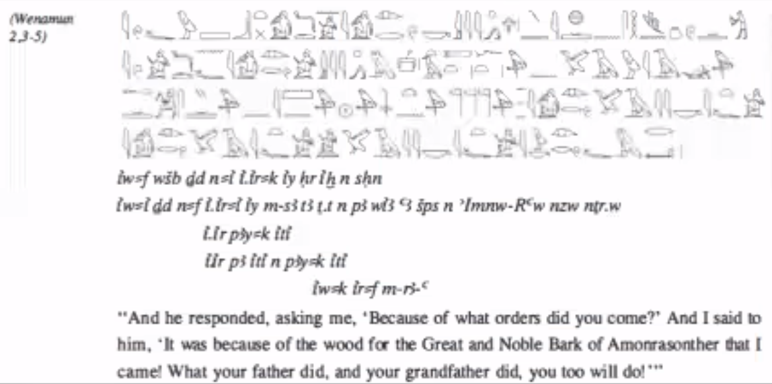

- Alex Lorenz: What form of the Egyptian language is inscribed on the Rosetta Stone? Foy: Technically ME because they were trying to write in a higher register

**4/30/2024**

[missed most of this class due to an airplane flight]

- r pw means “or”

- typical use of aHa.n construction:

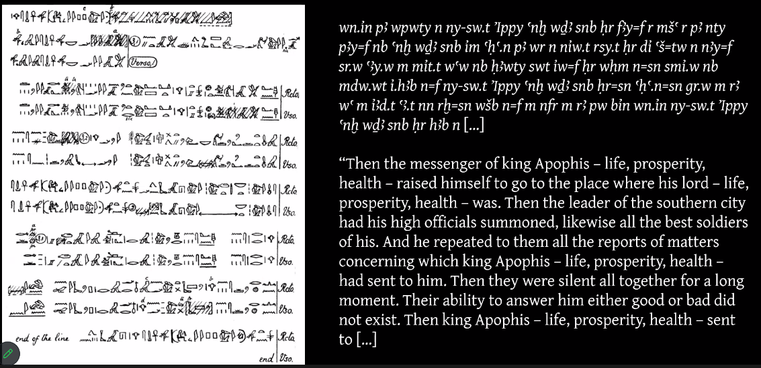

- BA-Nb-+d is Smendes I in the Third Intermediate Period, circa 1100 BCE

- in the example below, tw must be a subject, identifying this clause as second-tense, but that’s not clear until you go through the rest of the clause:

i.ir=tw wpw.t=w m sp tpy m tA wsx.t Wa MAa.w

It was in the first time in the hall, Unique of Truths, that they were judged.

- underlining in transcription/transliteration means rubric text

- v° 4.2 in annotation means “verso, column 4, line 2”

- why did the start of the name +Hwty sound like “th” to Ptolemaic Greeks? remember t, T, d, D merging into tH

- the only “Greek” thing about the names Isis and Osiris is the declensional endings

- another example: Petekhons becomes Petekhonsis

- where to go from here:

choose a reading out of Gardiner’s Late Egyptian Stories or Late Ramesside Letters

work through the text with a translation and/or help like the Ramses database

make vocab and sign lists

parse everything